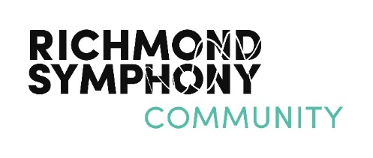
In Tune with the Northside: Celebrating its History and People
Bryan Park: Saturday, September 8, 2018
Performance Application
The Richmond Northside Festival 2018, In Tune with the Northside: Celebrating its History and People, in conjunction with the Richmond Symphony, seeks to showcase talented artists, outstanding school programs and exceptional community groups during a one day festival to be held September 8, 2018 in Bryan Park. This festival will feature the Richmond Symphony’s state-of-the art mobile stage known as the “Big Tent” and will include a variety of music, dance, theater performances, art exhibits, booths, food trucks, and other creative activities. All interested artists and groups are asked to complete the following information to apply to participate:

Group/Individual Name: ___________________________ How many are in your group? _________

Contact Person/Title: ___________________________________________________________________

Contact Phone: _________________________________________________________________________

Email: _________________________________ Website: ______________________________________

Facebook: ______________________________ YouTube: _____________________________________

Please confirm that you are able to perform on September 8, 2018. If there is a
time that you are NOT available to perform, please indicate below, along with any other comments or notes.
________________________________________________________________________________________________________________________________________________________________________________________________________________________________________________________________________________________________________________________________________________________________________________
Please note the following:
- Professional quality lighting, staging, and sound to be provided by the Richmond Symphony.
- If chosen to perform, between 20 - 45 minutes of performance time will be allocated
- If possible, please include a link to a video/audio representation of your work.
- Additional equipment may be available upon request.
- Submit “Performance Application” as soon as possible but no later than July 20, 2018
- Submit form to: Anna Strahs Watts, Richmond Symphony at astrahswatts@richmondsymphony.com or fax to 804.788.1541
- All performing artists will be notified by August 8, 2018 if asked to perform.
- For questions contact Anna Strahs Watts, Community Partnerships Manager, Richmond Symphony at 804.788.4717 x 141 or email astrahswatts@richmondsymphony.com

