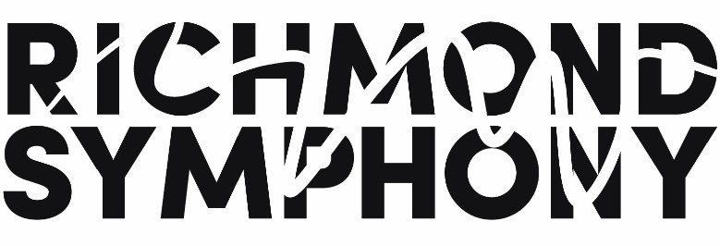

Title | Production and Logistics Coordinator, Menuhin Competition Richmond 2020 | Reports To | Project Manager, Menuhin Competition Richmond 2020
Department | Menuhin | Classification | Contracted through May 2020

Job Summary
General statement regarding the overall function, scope and purpose of the work to be performed.

The Production and Logistics Coordinator for the Menuhin Competition Richmond 2020 is responsible for the coordination of stage management, production and logistics related to the Competition across six different venues and five partners, which will be held on May 14-24, 2020. The Menuhin Competition is the world’s leading international competition for young violinists, and is often known as “The Olympics of the Violin.” This position will reside in the Richmond Symphony offices and work closely across departments including Operations staff and the existing and future Menuhin Competition Richmond 2020 staff. This position may be hired as full or part-time, depending on the availability of the successful candidate; duties may be adjusted accordingly. Duties connected with this position include but are not limited to:

Responsibilities/Duties/Functions/Tasks

- Coordinate production and stage management plans among Menuhin Competition Richmond 2020 partners and Menuhin Competition Trust
- Oversee recruitment and volunteer management
- Manage production/logistics interns and volunteers
- Manage room and hall schedules and layout for all venues for Menuhin Competition Richmond 2020
- Manage daily schedules during the Competition
- Coordinate instrument rentals, moves, and tunings
- Work with local partners and Menuhin Trust to coordinate catering
- Coordinate vehicles and local transport management for competitors, jurors, artists and staff
- Act as primary liaison to hall staff and production crew from local partners and competition venues
- Perform other duties as assigned by the RSO Director of Artistic Planning and Orchestral Operations and the Project Manager for the Menuhin Competition Richmond 2020

Qualifications

Successful performance in this position requires an individual with the following demonstrated skills:

- Experience in production and stage management
- Knowledge of music performance etiquette and protocols
- Ability to work with artists of all ages with sensitivity and judgement
- Proven track record of effective time management, flexibility and strong organizational skills
- Commitment to the principles of teamwork and shared responsibility
- Ability to communicate effectively
- Ability to anticipate problems or to identify them before significant impacts occur

Environment

- Position will have work space in the Richmond Symphony office (parking provided)
- Work is performed in a fast-paced office environment
- During and in the weeks leading up to the Menuhin Competition Richmond 2020 (May 14-24, 2020), attendance and participation will be expected outside of normal office hours and on weekends
- The Richmond Symphony strives to create an environment that practices shared values inclusive of the following: Mutual Respect, Empathy, Integrity, Transparency, Trust, Insistence on Excellence, Hunger for Success, Passion, Creativity and Fun

To Apply

Please send cover letter and resume to mfogel@richmondsymphony.com. Phone calls will not be accepted.

