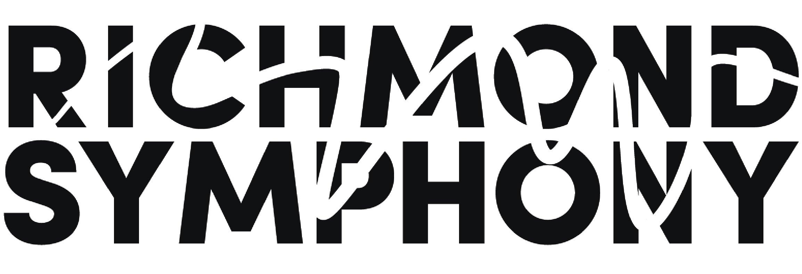

Title | Donor Relations Assistant | Reports To | Donor Relations Manager
Department | APC | Classification | Full time salaried / Non exempt
Job Summary

The Richmond Symphony makes music an integral part of the lives of those living, learning and working here by embracing the Richmond region’s unique vitality and diverse constituents.

The Richmond Symphony seeks a music loving and organized individual to serve as the Donor Relations Assistant to join its friendly advancement team.

Under the supervision of the Donor Relations Manager, the Assistant is responsible for a variety of administrative tasks to support the Advancement team (part of the Advancement and Patron Communications department) with overall fundraising, prospecting, and donor stewardship work.

Day to day responsibilities of the Assistant includes data entry and reporting, managing volunteer opportunities, supporting fundraising campaigns, working concerts, and assisting with the execution of special events.

The Richmond Symphony is an Equal Opportunity Employer. The Symphony embraces diversity and equal opportunity in a serious way. We are committed to building a team that represents a variety of backgrounds, perspectives and skills.

Responsibilities

- Assists in the execution of the individual giving solicitation cycle including direct mail / phone campaigns and donor cultivation procedures
- Management of accurate data across company databases
- Creates compelling stories and content for different stakeholders
- Assists in executing special events
- Serves as the first point of entry for the donor database including inputting transactions, tracking cultivation touch points, generating acknowledgement letters, etc.
- Organizes volunteer opportunities for solicitations and cultivation processes, (e.g. envelope stuffing, phone banking.)
- Provides staff support to select Board meetings and committees including:
  - - Coordinating meetings both in person and online via Zoom
  - - Recording and distributing minutes for both Board and committee meetings
  - - Distributing electronic material and other correspondence needed in advance of Board and committee meetings
- Maintains a visible presence at concerts and cultivation events as appropriate
- Providing aid in developing presentation materials
- Booking appearances and public speaking engagements as appropriate
- Support events managed by the Richmond Symphony League
- Performs other duties as assigned by Director of Advancement and Patron Communications

Qualifications

Successful performance in this position requires an individual with excellent organizational skills, including attention to detail and efficient time management. A successful candidate can collaborate creatively and work effectively with internal and external partners, and execute tactical activities that accomplish departmental and organizational goals.

Other qualifications include:
- Proven track record of effective time management, flexibility and strong organizational skills
- Good and compelling writing skills – experience in copy or ghost writing a plus
- Commitment to the principles of teamwork and shared responsibility
- Ability to multi-task and meet simultaneous deadlines
- Ability to act with discretion in handling confidential conversations, correspondence and records
- Ability to relate to a diverse group of people including staff, musicians, members of the board, and community members
- Ability to communicate effectively both orally and in writing
- Ability to proactively identify and relay issues to other members of the Advancement team
- Experience with non-profits
- Experience working in customer relationship management (CRM) databases – Bloomerang preferred
- Experience with classical music organizations preferred

Environment

- Position will a dedicated have work space in the Richmond Symphony office.
- Parking provided.
- Some flexibility regarding remote working is available, however this role is largely office based due to the nature of the work.
- Work is performed in a friendly and fast paced hybrid office environment.
- Attendance and participation at concerts, events and activities will be expected
- Benefits include health insurance, self-funded dental insurance, 403(b) account, paid time off, optional instrument insurance, free parking
- Salary $32,000.
- To apply, please send a cover letter & resume to development@richmondsymphony.com
- The position will remain open until filled.

