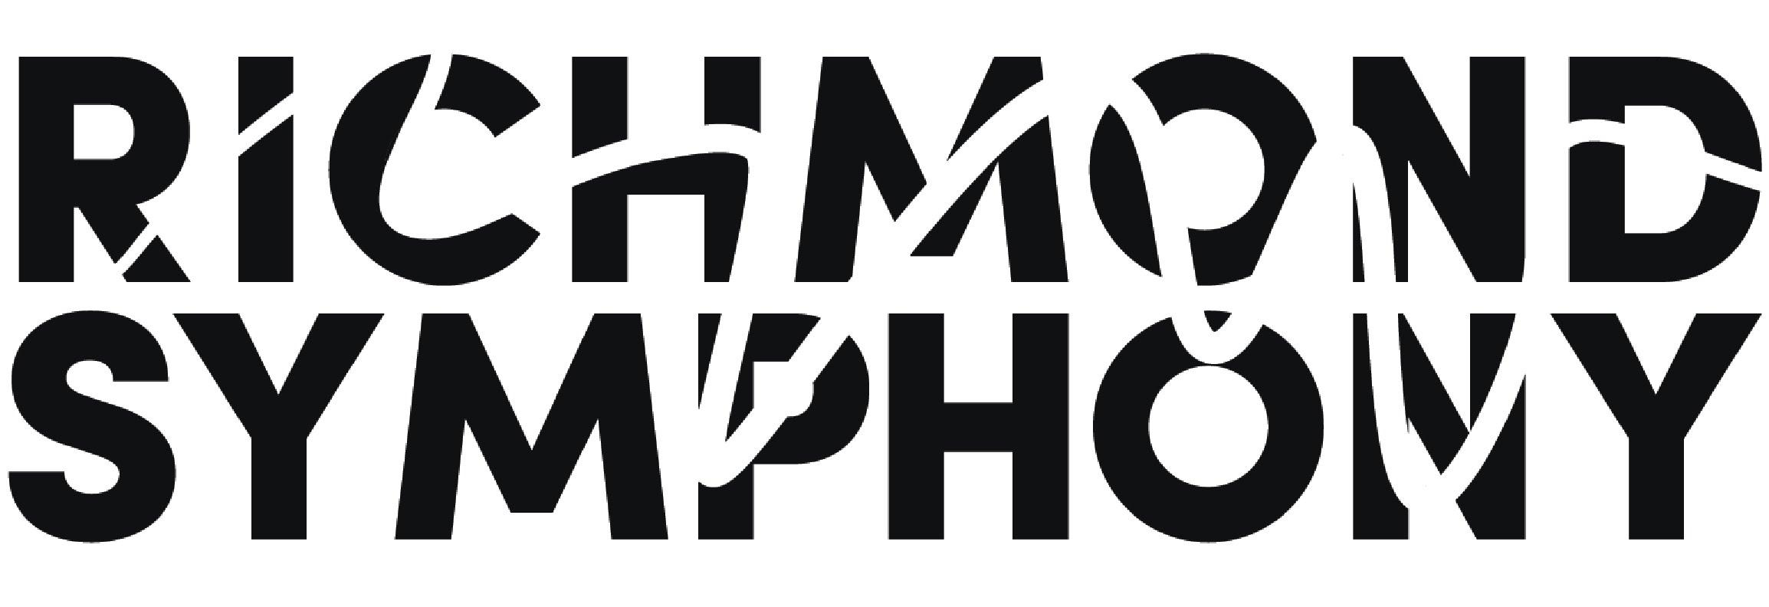

Title | Grants and Foundations Coordinator | Reports To | Donor Relations Manager
Department | APC | Classification | Full time salaried / non exempt

Job Summary

The Richmond Symphony makes music an integral part of the lives of those living, learning and working here by embracing the Richmond region’s unique vitality and diverse constituents.

The Richmond Symphony seeks a music loving and organized individual to serve as the Grants and Foundations Coordinator to join its friendly advancement team.

The position sits within the Advancement team, (part of the Advancement and Patron Communications department) and is responsible for the Symphony’s foundation and government grantor relationships, funding applications and reports with an annual goal of $600,000 or more, seeking new funders, and assisting the organization and advancement team with other duties to reach its annual fund goal.

The Richmond Symphony is an Equal Opportunity Employer. The Symphony embraces diversity and equal opportunity in a serious way. We are committed to building a team that represents a variety of backgrounds, perspectives and skills.

Responsibilities

- Research and write grant applications with a revenue goal of at least $600,000
- Manage the tracking of existing grants and reporting through the organization’s donor database
- Seek additional grant opportunities as appropriate
- Prepare renewal grants as applicable with local, state and federal government agencies
- Edit draft applications for accuracy and completeness in accordance with grant requirements
- Work collaboratively with Advancement and other departmental staff to implement funding strategies
- Cultivate giving opportunities with local associations such as Rotary Clubs, Kiwanis etc
- Prepare reports as required by funders
- Organize volunteer opportunities for solicitations and cultivation processes, e.g. envelope stuffing, phone banking, etc.
- Provide staff support to select Board meetings and committees including:
    - Coordinating meetings both in person and online via Zoom
    - Recording and distributing minutes for both Board and committee meetings
    - Distributing electronic material and other correspondence needed in advance of Board and committee meetings
- Maintain a visible presence at concerts and cultivation events as appropriate
- Support the advancement team with special events and other fundraising activities

Qualifications

- At least 1 year’s proven track record of writing and delivering grant applications for non-profit organizations (arts preferred)
- Experience of Greater Richmond and Virginia government and foundation funders desirable
- Strong project/time management skills
- Excellent verbal and written skills
- Excellent software skills in Google and Microsoft programs
- Commitment to the principles of teamwork and shared responsibility
- Ability to act with discretion in handling confidential conversations, correspondence and records
- Ability to relate to a diverse group of people including staff, musicians, members of the board and foundation, and community members
- Experience working in customer relationship management (CRM) systems (Bloomerang preferred)
- Experience with classical music preferred

Environment

- Position will a dedicated have work space in the Richmond Symphony office
- Flexibility regarding remote working is available – two days per week are required in office
- Work is performed in a friendly and fast paced hybrid office environment.
- Attendance and participation at concerts, events and activities will be expected
- Benefits include health insurance, self-funded dental insurance, 403(b) account, paid time off, optional instrument insurance, free parking
- Salary $36,000 - $38,000
- To apply please send a cover letter and resume to development@richmondsymphony.com
- The position will remain open until filled.

