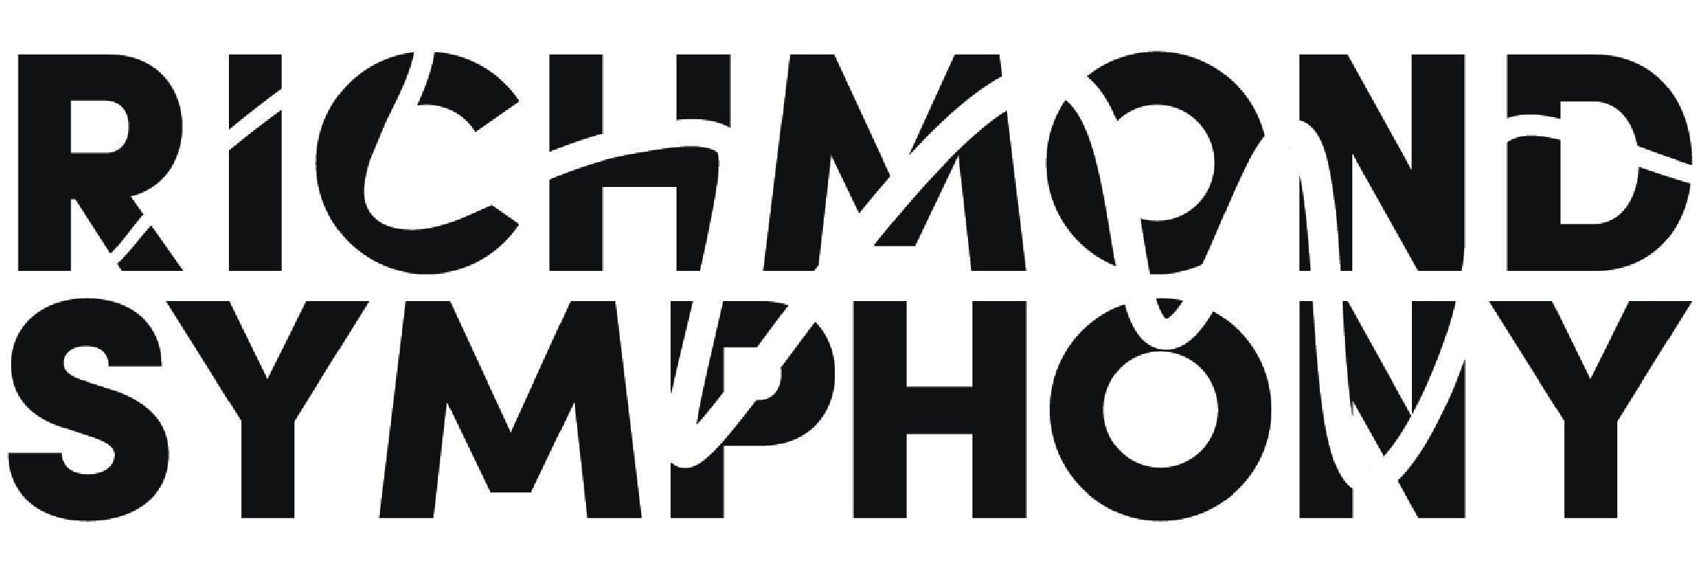

Title | Program Manager & Lead Instructor - Youth Community Strings | Reports To | Director of Education & Community Engagement
Department | Education & Community Engagement (EdCE) | Classification | Full Time

Job Summary

The Richmond Symphony seeks an energetic and organized individual to serve as the Lead Instructor for an exciting new Youth Community Strings initiative.

Our objective is to serve the city of Richmond and its surrounding communities through the implementation of a Community Strings program, offering young students the opportunity to learn a stringed instrument at no cost. In addition to after-school music lessons, the program will provide students with a sense of inclusion, belonging, and community through music.

This exciting opportunity drives the symphony’s strategy to develop programming and educational initiatives that increase access and participation throughout the region and that utilize music to activate more community spaces and serve more residents.

The Program Manager & Lead Instructor is responsible for spearheading the initiative, designing the curriculum, recruiting students and families, teaching and supervising instruction, as well as the day-to-day administrative and logistical support to maintain and grow the program.

Education and Community Engagement staff work as a team, and the Program Manager & Lead Instructor will be inspired by working collaboratively and building this shared vision to support student achievement in the arts. They work closely with the Director of EdCE, the EdCE team, symphony staff and musicians..

The Richmond Symphony is an equal opportunity employer. We celebrate diversity and are committed to creating an inclusive environment for all employees.

Responsibilities/Duties/Functions/Tasks

- Drive preliminary planning including site identification and selection, recruitment, and development of community relationships in alignment with the Richmond Symphony Strategy and in collaboration with EdCE staff
- Design and develop all aspects of the program, including, but not limited to:
  - Develop beginning to intermediate strings and general music curriculum
  - Create and implement lesson plans
  - Teach classes and/or arrange for instructors as needed
  - Attend to and maintain student instruments and supplies
  - Manage program budget and expenses
  - Contribute to development and marketing efforts
  - Recruit students and represent the program to the community
  - Correspond with parents/guardians, partnering schools, and local music educators
- Communicate effectively and proactively with Richmond Symphony staff and musicians, and community partners
- Assist with the production of other Richmond Symphony, Education, and Community Engagement programs as assigned

Qualifications

The successful candidate will be an accomplished teaching artist with a concentration on a bowed stringed instrument. They solve problems creatively, are detail-oriented and well-organized, and have a passion for music and empathy necessary to work with young children. Moreover, they are driven by the belief that music is for everyone.

The following qualifications are required:
- Proven track record of success working with children and parents in an educational setting
- Experience working effectively with students from a variety of socioeconomic and cultural backgrounds
- Proven track record of effective time management, flexibility and strong organizational skills
- Flexibility to work independently, as a leader, and as a member of the team
- Ability to multi-task and meet simultaneous deadlines
- Ability to act with discretion in handling confidential conversations, correspondences and records
- Ability to communicate effectively, both orally and in writing
- Familiarity with basic office computer applications such as Word, Excel, Powerpoint, Google docs, Google calendar

The following qualifications are desirable but not essential:
- Bachelor’s (and Master’s) degree in music performance or music education
- Previous office administrative and/or managerial experience
- Familiarity with music software and music notation software

Environment, Benefits & Salary

- Position will operate flexibly in a variety of environments including classroom spaces on site for the program, Richmond Symphony offices, and remotely as appropriate.
- Attendance and participation at concerts, events and activities will be expected outside of normal office hours and on weekends
- Full-time employees are eligible for company benefits, including health insurance, dental insurance, telemedicine and vision benefits, flexible spending or health savings accounts, disability insurance, company holidays, sick and vacation time off, and a 403(b) plan. The Symphony will provide parking in a lot near the Dominion Energy Center.
- Salary $45K annually
- Flexible start date

How to apply
- Applicants must submit a resume, cover letter and at least 2 professional references
- Application review continues until the position is filled
- Any offer of employment is contingent upon background check
- Please submit materials to education@richmondsymphony.com

